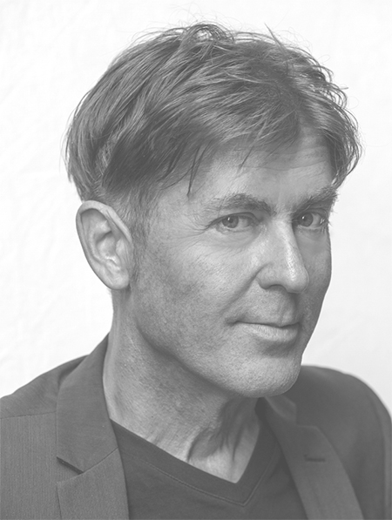 | m a r k e. s w I n d l e  UX Specialist | UX Architect  UX Solution Lead | UX Designer  Information Architect | (312) 212-3346  markswindle@gmail.com  markswindle.net  linkedin.com/in/swindle  Chicago, IL
________________________________________________________________________________________________
UX Specialist backed by super-solid UI, IA, PM and design skills. A quick study, fully-engaged from the get-go, who pursues of project excellence while respecting deadlines and budget. And an infuser of levity when projects get too serious!
work experience  2015–2017  UX Solution Lead, Senior UX Designer Aon Hewitt  Begun as a 4-month assignment as Sr UX Designer, this morphed into 24 months as UX Solution Lead, with salvage of a floundering re-design (Your Spending Account). Guided designers, writers and an offshore development team in requirements, visioning, prototyping, usability testing, sponsor negotiations, CX/accessibility/sponsor reviews and the governance process to create exemplary, top-testing products.  2010–2015  UX Architect, Designer, IA, PM design-i  Consultant for Columbia University, Northwestern University, John Jay College, The MacArthur Foundation, The American Assembly, Operation Smile, etc. on complex, content-rich, interactive and historical-archival websites and web app projects, coordinating worldwide-distributed teams.  2013–2014  CEO, UX/Visual Designer, Digital/Marketing Strategist Cinewav  Led a video-on-demand start-up addressing the excess of cinematic content by leveraging premier film festivals as the optimal filtering tool, pursuing a relationship with the 90-plus% of festival filmmakers without a distribution outlet. Invited in at the concept stage, then guided the project to a Round 1 $250k investment, formulating marketing and distribution strategy, creating prototypes, and assisting in financial modeling.  2004–2010  Senior Web Designer Northwestern University, School of Education & Social Policy  Design/development of complex historical & academic websites, custom web apps, promotional material & University-wide interdisciplinary projects; and expansion of SOCiety to include digital portfolios, profile engine, news center, accreditation functionality, etc.  2002–2004  Webmaster, Designer Northwestern University, School of Communication  Design and production of digital and print promotional content for the School, its departments, and research; architected a custom CMS, SOCiety, deployed across multiple schools and institutes; oversaw the management of dozens of websites for faculty, staff and researchers.  2000–2001  Senior Interactive Art Director Frankel & Company  Art direction and design of website and microsite projects for Tropicana, Target and Visa; and—in the nascient period of corporate web presence—coordination of print/web brand identity.  1998–2002  Web/Interactive Designer/Producer, Flash, Animator, Illustrator Aquent, Digital People, E-Staff, Randstad  Clients: Rand McNally, DDB Worldwide, Smith Bucklin & Associates, Neology, McGraw-Hill, Argonne National Laboratory, Giant Step, Quantum Leap, LeapNet, United Airlines, etc. |  | skills  - 5 - UX design  - 5 - Web design  - 5 - IA  - 5 - Wireframing  - 4 - Prototyping  - 4 - Responsive design  - 4 - Interactive design  - 4 - Project Management  - 4 - Writing for the Web  - 5 - Adobe Creative Suite  - 4 - Axure  - 3 - Visio  - 4 - HTML/CSS  - 3 - SQL  - 2 - PHP  - 2 - Javascript  proficiencies  - Low/Med/High fidelity  - Wireframing (web/tablet/mobile)  - HTML/Axure prototyping  - Storyboarding  - Journery mapping  - Workflows  - Personas  - Strategic thinking  - Start-up experience  - Business analysis  personal  - Passionate  - Engaged  - Enthusiastic  - Calm  - Expert communicator  - Team player  - Highly-organized  - Quick study  - Mood lightener  - Impasse breaker  - Humor infuser

